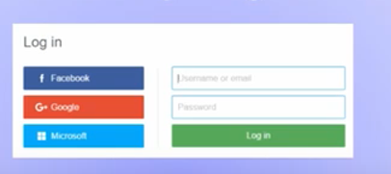

Identity providers

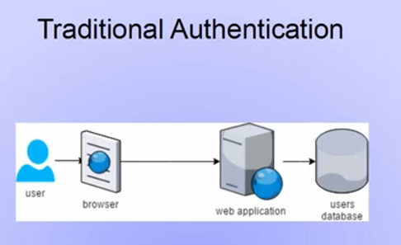

If user has account in diff web sites running on different servers each having own database, he should change the password for all regularly for security reasons

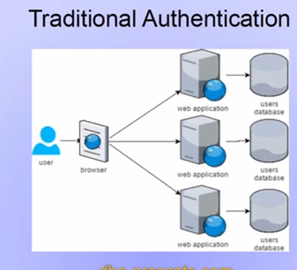

Would be easier if all websites use one database, he can have one password but should be done in such a way that none of the website should be able to access other website using user credentials.

This is done using a protocol called **OpenID**

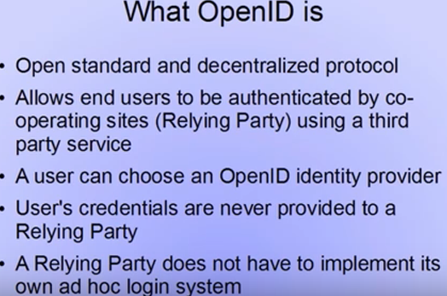

Many identity provider like google, facebook, twitter, Microsoft. User can identicate to a relying party using an identity provider. User can choose which provider. User password is never sent to the relying party as the authentication takes place on the identity provider’s page.

OAuth is a protocol which not only supports authentication but authorization also. User can agree to the relying party to get his/her limited profile data from an OAuth provider. If user does not agree this will not happen.

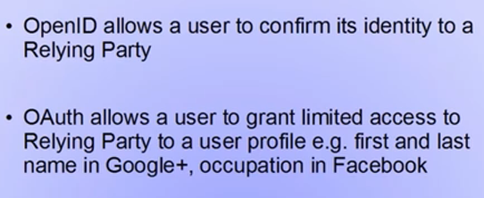

**OAuth2 algorithm**

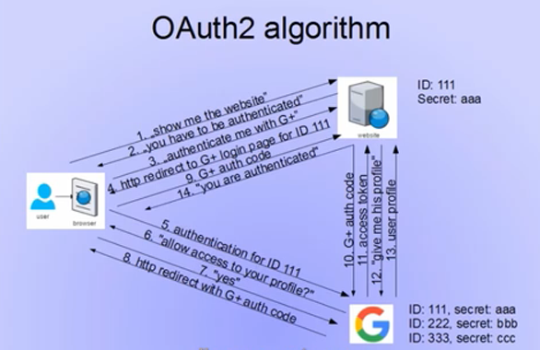

**Flipkart, amazon: G+**

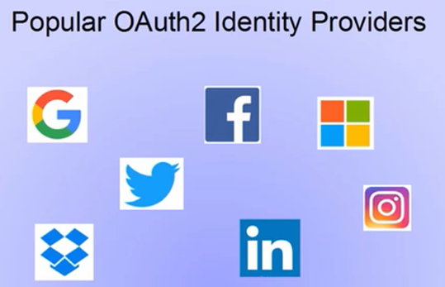

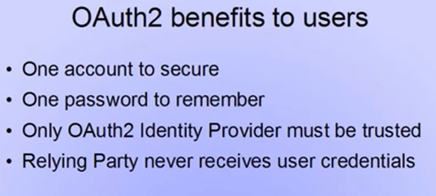

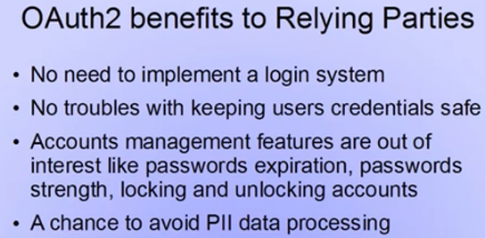

**Basic Security:**

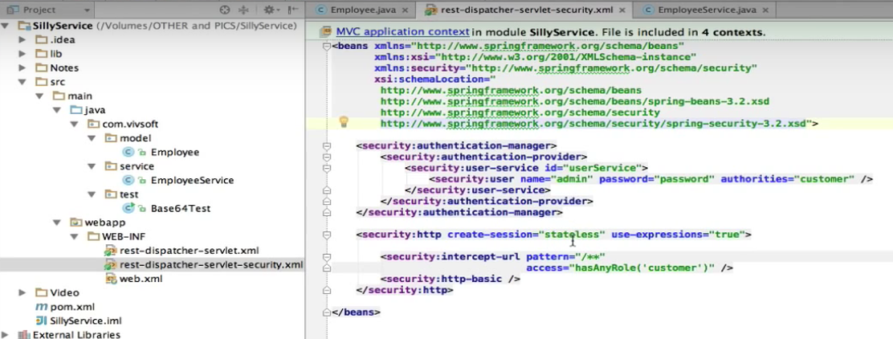

**OAuth2**

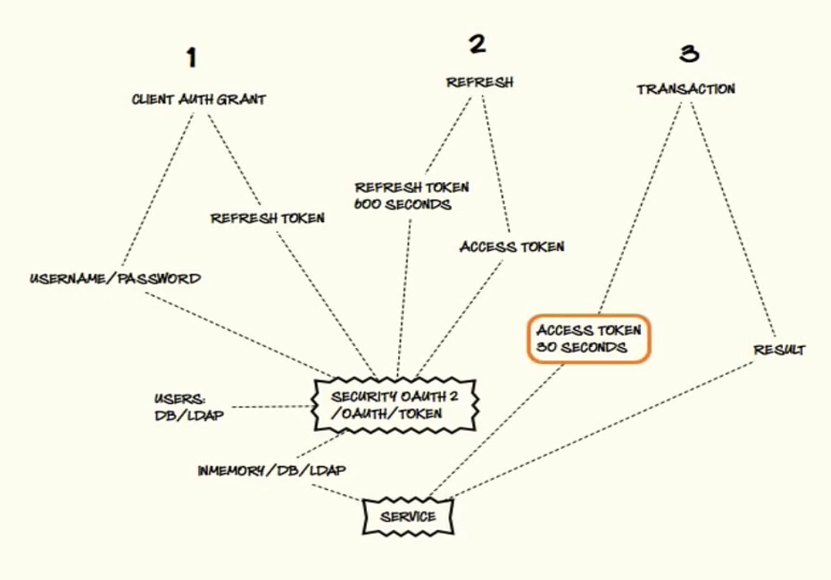

Refresh token for example expires in 90 days, he may be getting refresh from some site which is authenticating it like Facebook. Access token may be expiring in like 10 seconds.

In spring, we’ll not touch service layer. Instead of xml being configured for basic security, we’ll use the configuration for OAuth

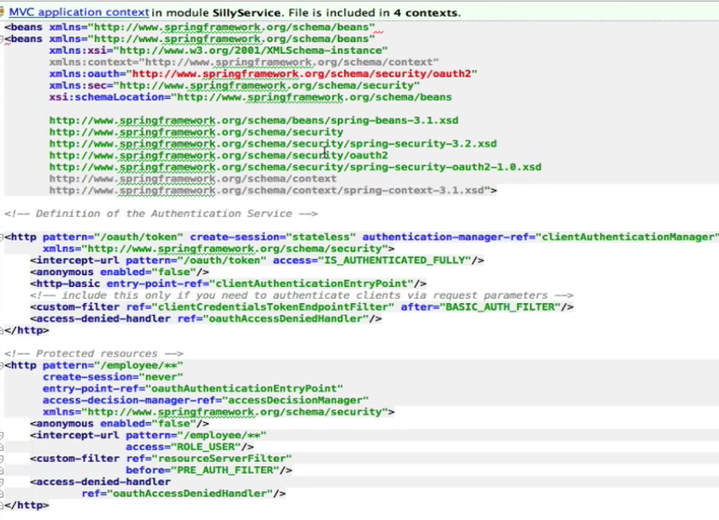

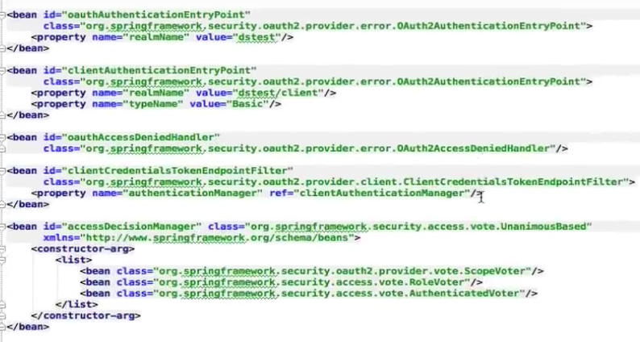

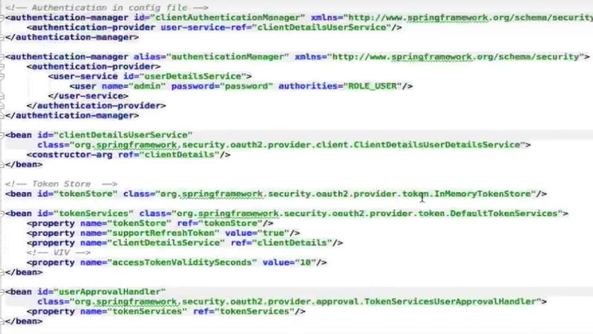

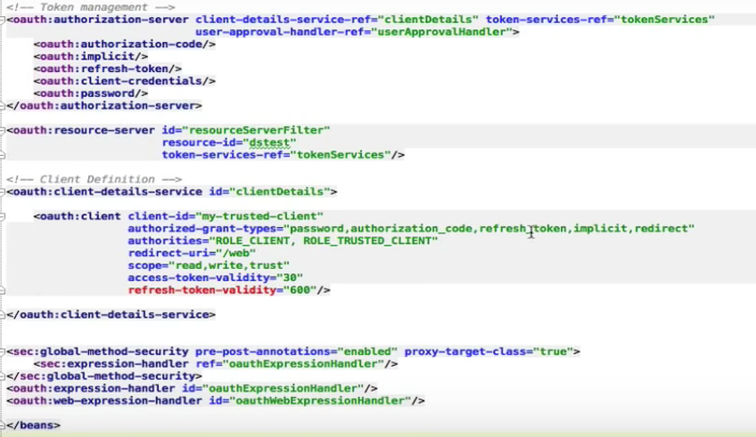

Dependency:

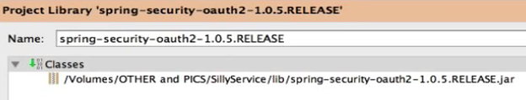

Step1: Go to Oauth service





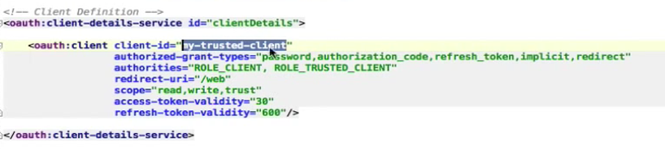

Send a request, will get back response:

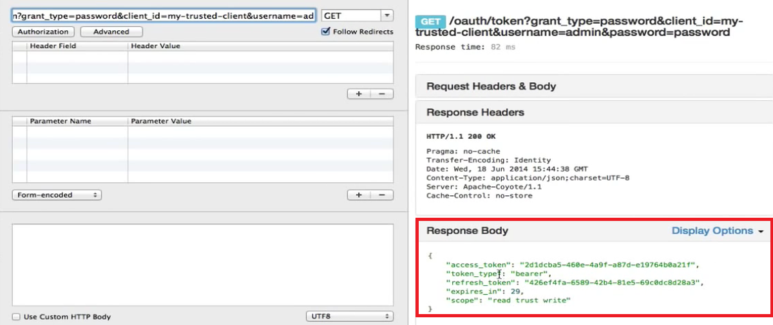

Step2: Sending refresh token:

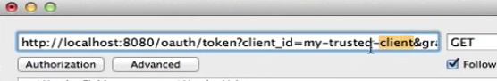





Will send this request and get back access token

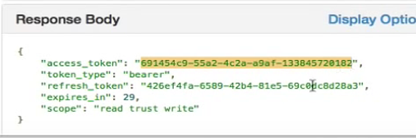

Step 3:

Now make a request to the service with the access token:

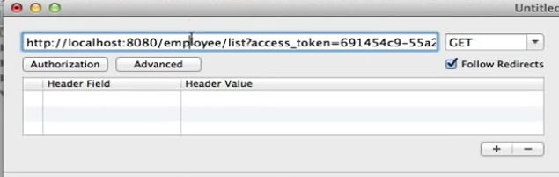

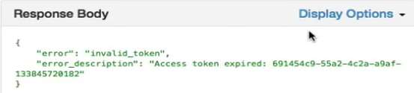

**Spring boot & spring security:**

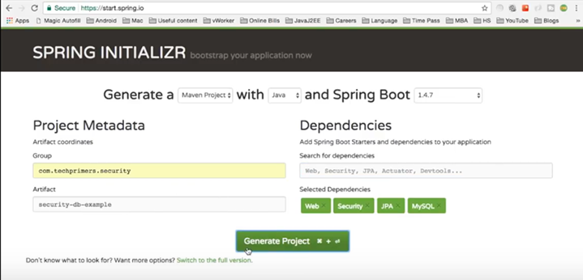

**Database Tables:**

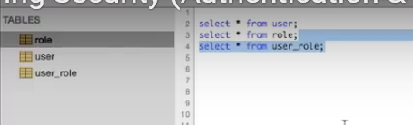

**Spring security:** Framework by spring to control authentication, authorization.

Oauth 8 steps: Authorization framework

1. Client credentials : Making api request for our own account
2. Authorization code: getting a token for another user’s account
3. Logging in via oauth
4. Oauth with facebook
5. Oauth in javascript with google+
6. Handling expired tokens
7. Using refreshed tokens
8. Tightening up security

Grant types:

Token:

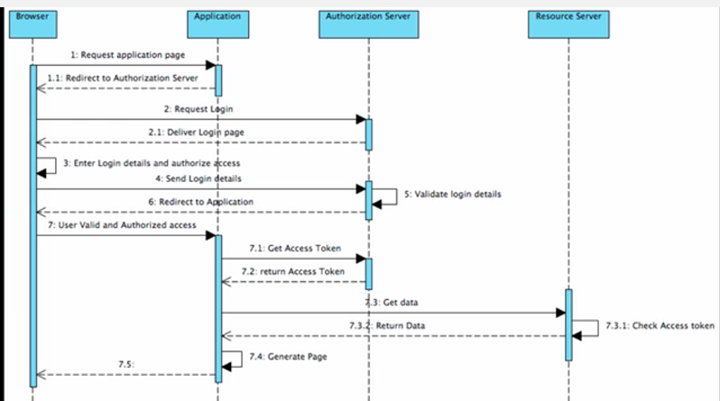

Access Token : to access api on behalf of user.

**OAuth Roles:**

1. Resource owner eg Picasa user
2. Resource server eg. Picasa hosting
3. Client eg. Mashup built for picasa
4. Authorization server : eg. Google Auth server

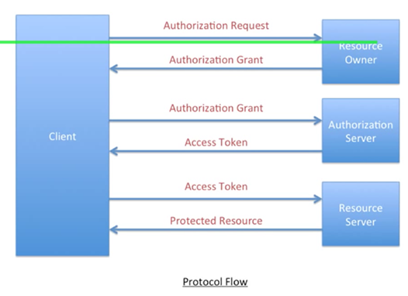

Access token has an expiry date.

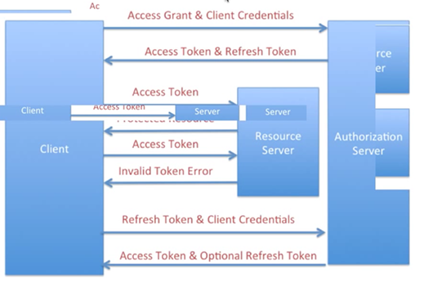

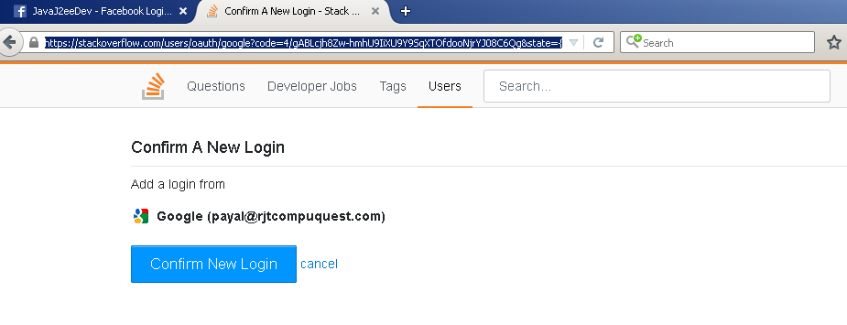

State:

Code: authorization code populated

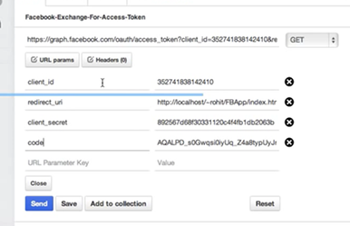

After send, gets access token and expiry

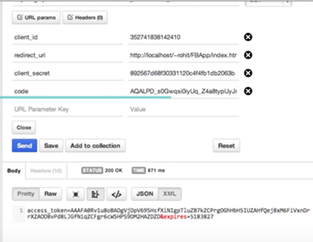

Send back the access token.

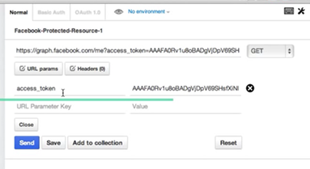

Send, will get your information

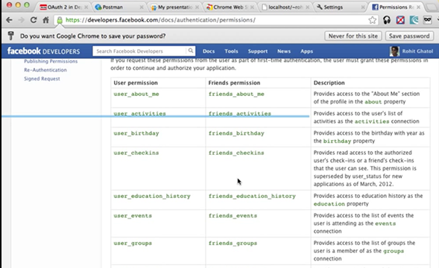

<https://developers.facebook.com/docs/facebook-login/web>

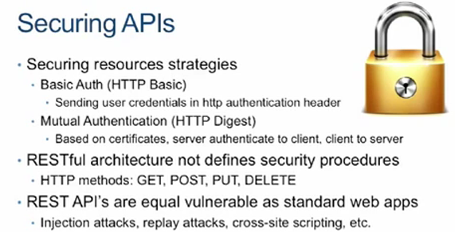

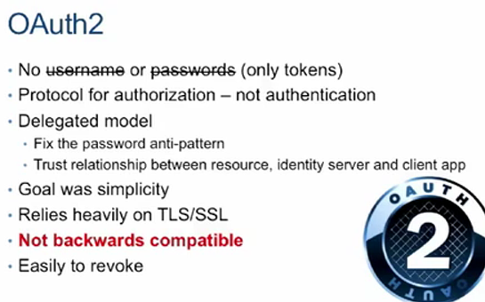

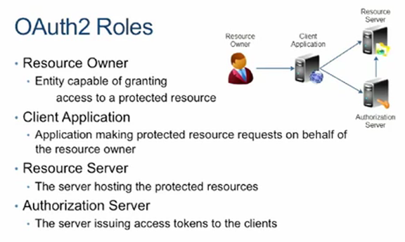

Resource server: twitter/ facebook

Authorization server: creates tokens, share tokens.

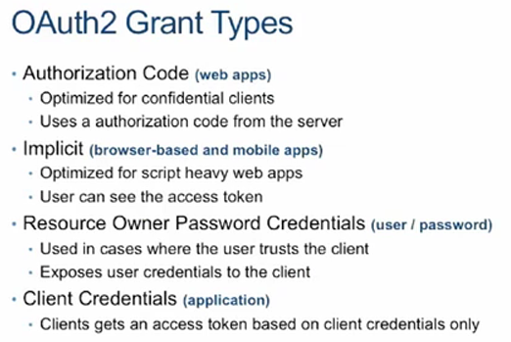

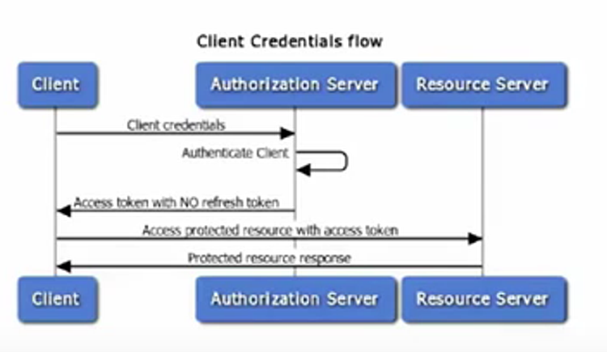

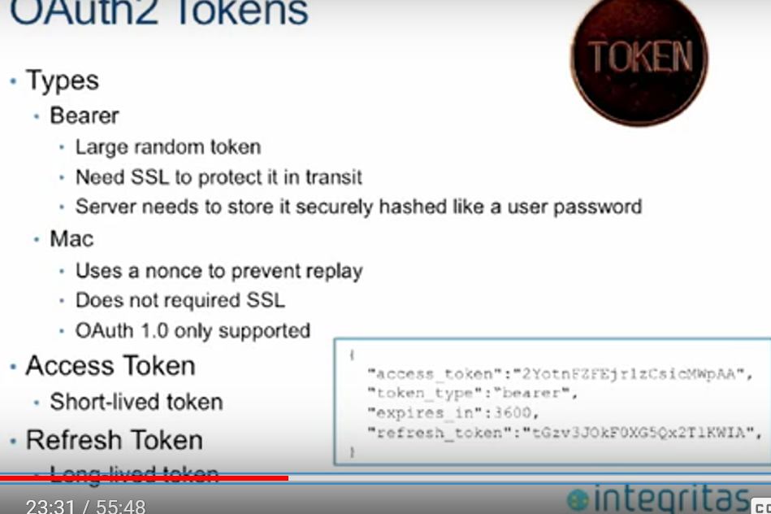

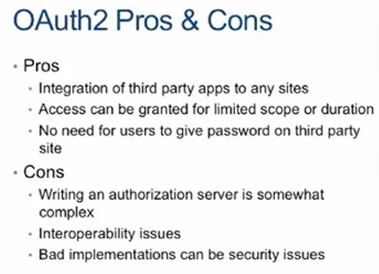

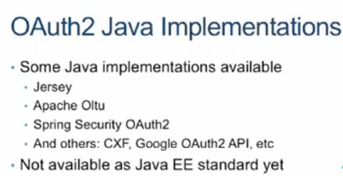

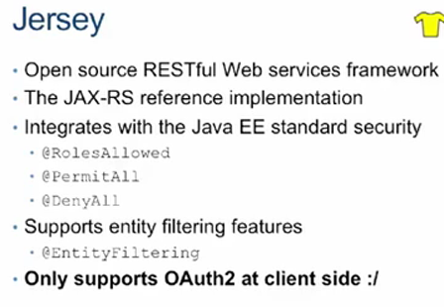

Eg: Filter json data.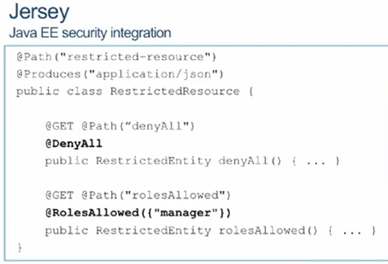

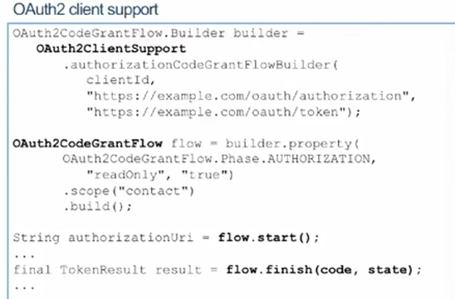

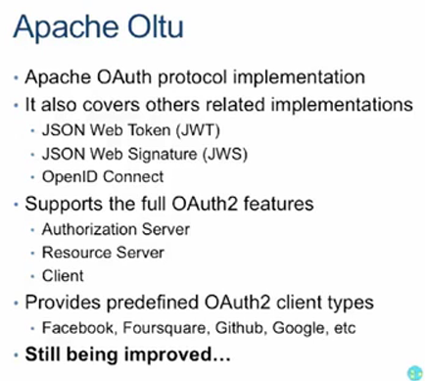

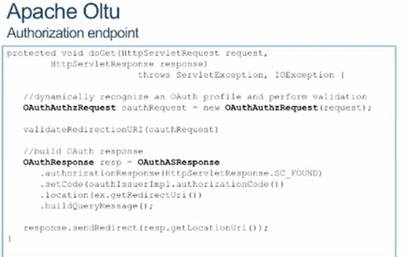

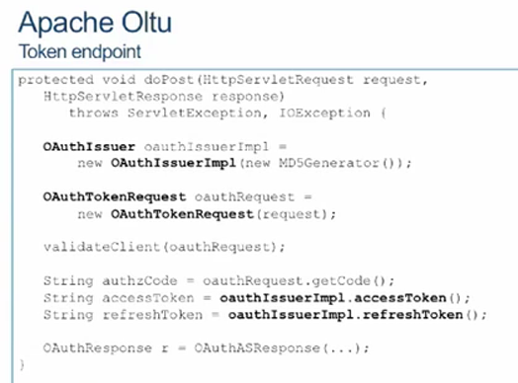

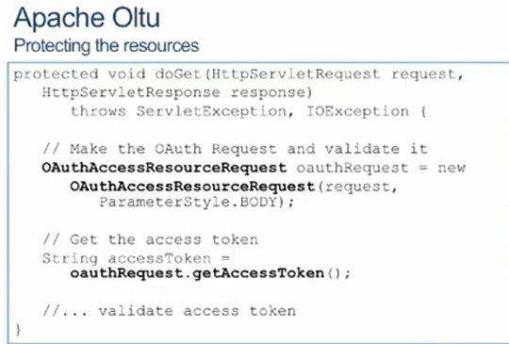

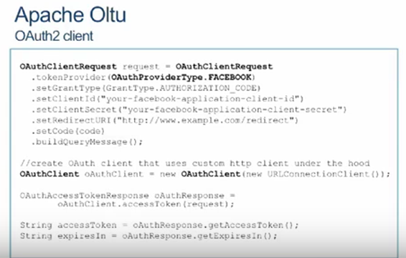

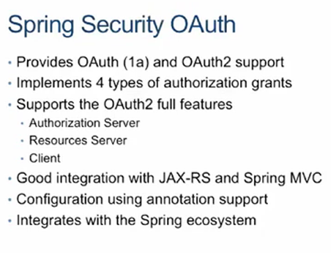

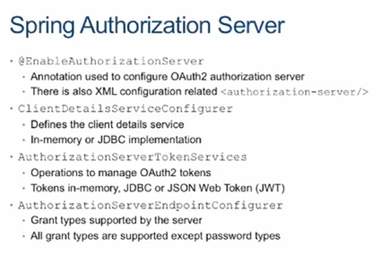

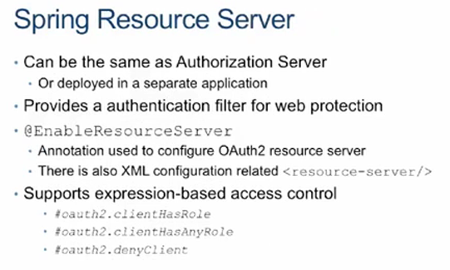

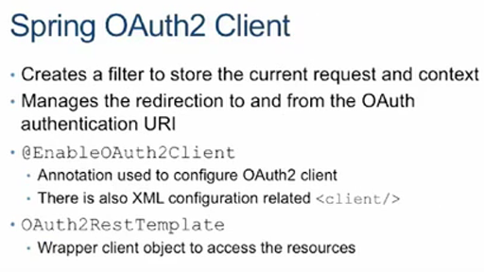

**Simple rest controller app security**

<dependency>

<groupId>org.springframework.boot</groupId>

<artifactId>spring-boot-starter-security</artifactId>

</dependency>

When we restart the application, we see following statements printed in the log.

Mapping filter: 'springSecurityFilterChain' to: [/*]

Using default security password: 25e07e82-720d-4109-ba8d-25177c6347e6

Creating filter chain:

...

...

All this magic is because of auto-configuration:

* Mapping filter: 'springSecurityFilterChain' to: [/*] : Spring Security is by default turned on for all the URLs in the application.
* Basic Authentication is the default.
* Using default security password: 25e07e82-720d-4109-ba8d-25177c6347e6 : The default user ID is 'user.' The default password is printed in the server's startup log. In this example, the password is: 25e07e82-720d-4109-ba8d-25177c6347e6
* Some filter chains are configured to enable security
* We will use two roles, Admin and User. The Admin role has access to the web application and the User role has access to execute REST Services.
* We will create one user for the Admin role with the credentials, admin1/secret1.
* We will create one user for the User role with the credentials, user1/secret1.
* 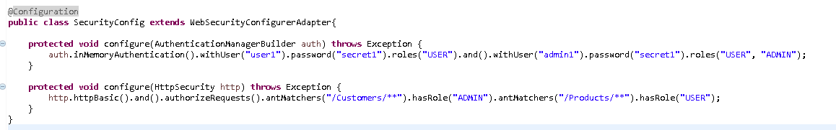

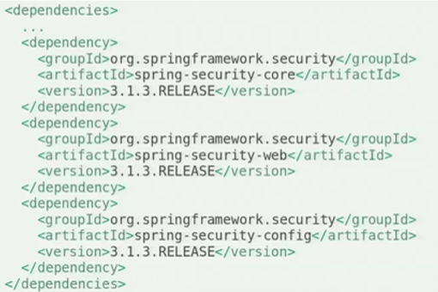

Spring-security-config enables declarative security.

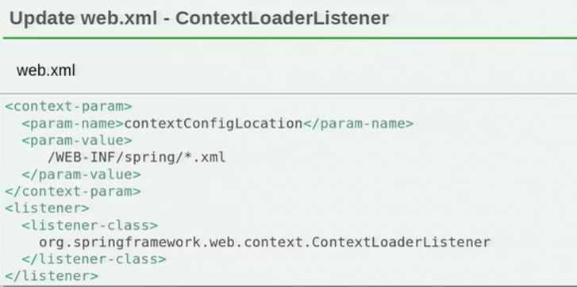

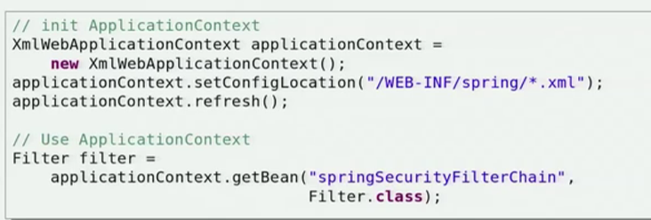

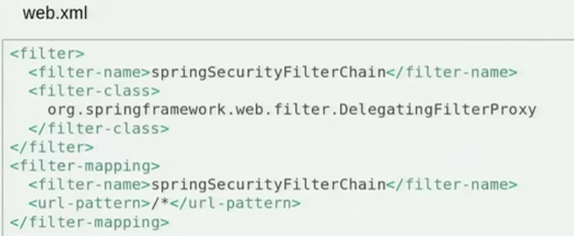

This should be placed before any filter mapping.

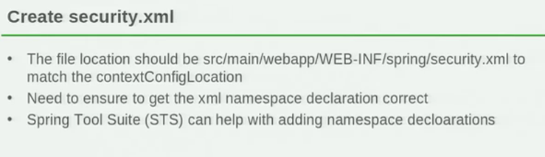

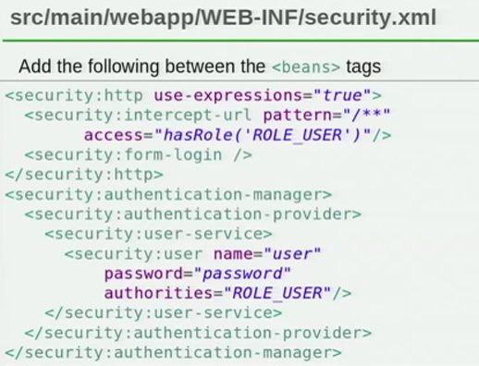

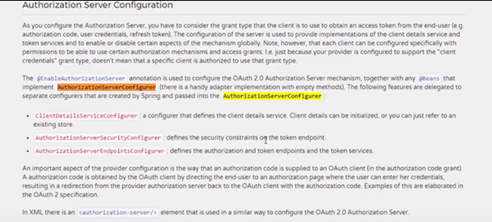

* Authorization Server (Responsible for authenticating your identity and gives you an authorization token, so that you can request resource server for your data with this token. this token is called access_token)

Authorization server will provide you two tokens if you user refresh_token as grant type. Now, what the hell is refresh token? What is the difference between access_token and refresh_token?

Well, the name says it all.

**Access Token And Refresh Token:**

This two types of token are provided by your authorization server. access_token is responsible for accessing your resources from the resource server. This token usually has a little validity time. You can access your data with this token a certain time before it get’s expired. So after it expires, you need to request Authorization server for a new access_token with your refresh token, client id, and client secret, so that you don’t need to send user credentials again and again. Refresh token has more validation time than Access Token. Typically 7-90 days, depends on you.

So we can say,

1. The responsibility of access token is to access data before it gets expired.
2. The responsibility of Refresh Token is to request for a new access token when the access token is expired.

**What will happen if my tokens are compromised?**

Since you can get access to your data with access_token, if it’s compromised then the hacker will get a very limited ability to get access to resources since it’ll be expired very soon.

If the refresh token is compromised, your resources are still safe because client id and client secret are needed to request for aceess_token, to get access to resources.

Well, now that we got the basic idea about OAuth 2 framework workflow. We’re gonna implement oAuth2 Authorization using Spring Security on Spring Boot.

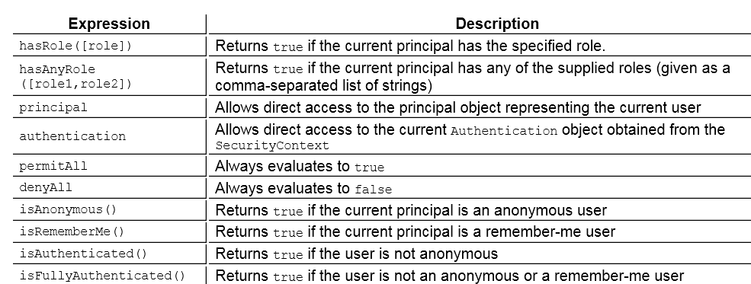

authorizedGRantTypes():("implicit","refresh_token", "password", "authorization_code")

authorization code, implicit, resource owner password

credentials, and client credentials

#### Authorization Code

The authorization code is obtained by using an authorization server

as an intermediary between the client and resource owner. Instead of

requesting authorization directly from the resource owner, the client

directs the resource owner to an authorization server (via its

user-agent as defined in [[RFC2616](https://tools.ietf.org/html/rfc2616)]), which in turn directs the

resource owner back to the client with the authorization code.

Before directing the resource owner back to the client with the

authorization code, the authorization server authenticates the

resource owner and obtains authorization. Because the resource owner

only authenticates with the authorization server, the resource

owner's credentials are never shared with the client.

The authorization code provides a few important security benefits,

such as the ability to authenticate the client, as well as the

transmission of the access token directly to the client without

passing it through the resource owner's user-agent and potentially

exposing it to others, including the resource owner.

#### [1.3.2](https://tools.ietf.org/html/rfc6749" \l "section-1.3.2). Implicit

The implicit grant is a simplified authorization code flow optimized

for clients implemented in a browser using a scripting language such

as JavaScript. In the implicit flow, instead of issuing the client

an authorization code, the client is issued an access token directly

Hardt Standards Track [Page 8]

[RFC 6749](https://tools.ietf.org/html/rfc6749) OAuth 2.0 October 2012

(as the result of the resource owner authorization). The grant type

is implicit, as no intermediate credentials (such as an authorization

code) are issued (and later used to obtain an access token).

When issuing an access token during the implicit grant flow, the

authorization server does not authenticate the client. In some

cases, the client identity can be verified via the redirection URI

used to deliver the access token to the client. The access token may

be exposed to the resource owner or other applications with access to

the resource owner's user-agent.

Implicit grants improve the responsiveness and efficiency of some

clients (such as a client implemented as an in-browser application),

since it reduces the number of round trips required to obtain an

access token. However, this convenience should be weighed against

the security implications of using implicit grants, such as those

described in Sections [10.3](https://tools.ietf.org/html/rfc6749#section-10.3) and [10.16](https://tools.ietf.org/html/rfc6749#section-10.16), especially when the

authorization code grant type is available.

#### [1.3.3](https://tools.ietf.org/html/rfc6749" \l "section-1.3.3). Resource Owner Password Credentials

The resource owner password credentials (i.e., username and password)

can be used directly as an authorization grant to obtain an access

token. The credentials should only be used when there is a high

degree of trust between the resource owner and the client (e.g., the

client is part of the device operating system or a highly privileged

application), and when other authorization grant types are not

available (such as an authorization code).

Even though this grant type requires direct client access to the

resource owner credentials, the resource owner credentials are used

for a single request and are exchanged for an access token. This

grant type can eliminate the need for the client to store the

resource owner credentials for future use, by exchanging the

credentials with a long-lived access token or refresh token.

#### [1.3.4](https://tools.ietf.org/html/rfc6749" \l "section-1.3.4). Client Credentials

The client credentials (or other forms of client authentication) can

be used as an authorization grant when the authorization scope is

limited to the protected resources under the control of the client,

or to protected resources previously arranged with the authorization

server. Client credentials are used as an authorization grant

typically when the client is acting on its own behalf (the client is

also the resource owner) or is requesting access to protected

resources based on an authorization previously arranged with the

authorization server.

<https://tools.ietf.org/html/rfc6749#section-1.2>

**Oauth2 security**

<dependency>

    <groupId>org.springframework.security.oauth</groupId>

    <artifactId>spring-security-oauth2</artifactId>

    <version>${oauth.version}</version>

</dependency

<dependency>

    <groupId>org.springframework</groupId>

    <artifactId>spring-jdbc</artifactId>

</dependency>

<dependency>

    <groupId>mysql</groupId>

    <artifactId>mysql-connector-java</artifactId>

    <scope>runtime</scope>

</dependency>

we’re using spring-jdbc and MySQL because we’re going to use a JDBC backed implementation of the token store

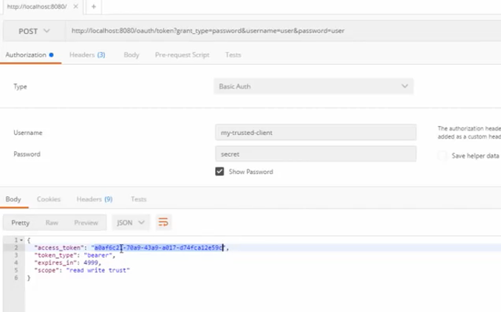

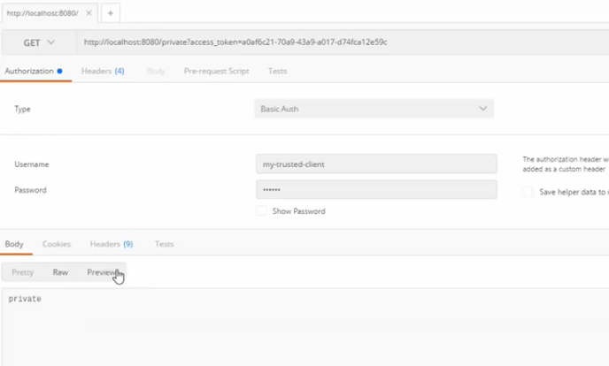

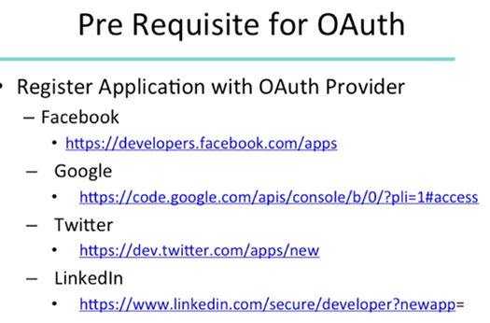

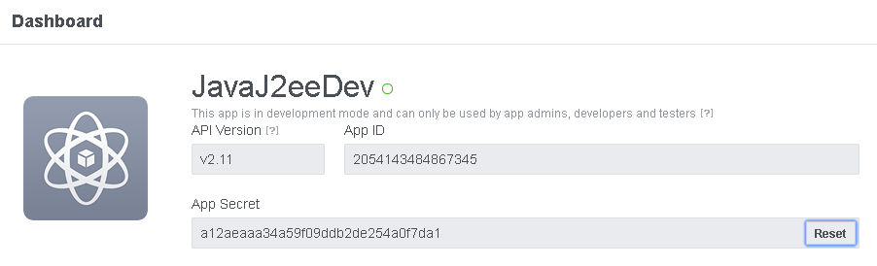

This is like a password, should not share and also needs a redirect url.

